**How to Build an Information Centre in Spark AR Studio with Patches and Spark AR Library.**

Open spark AR studio and crate a blank project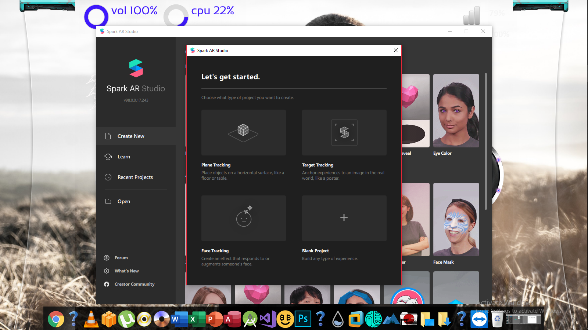

Add a plane tracker to the Scene panel

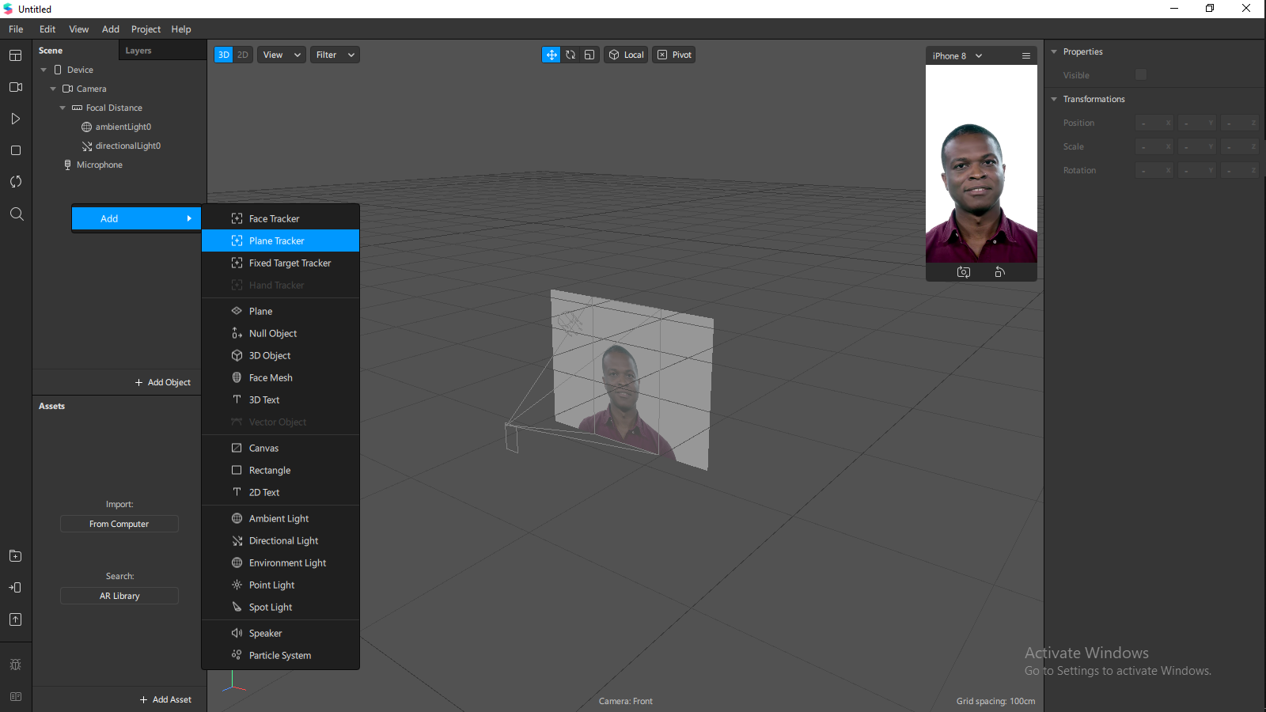

Add a Null Object to the scene panel and rename it to Interactions

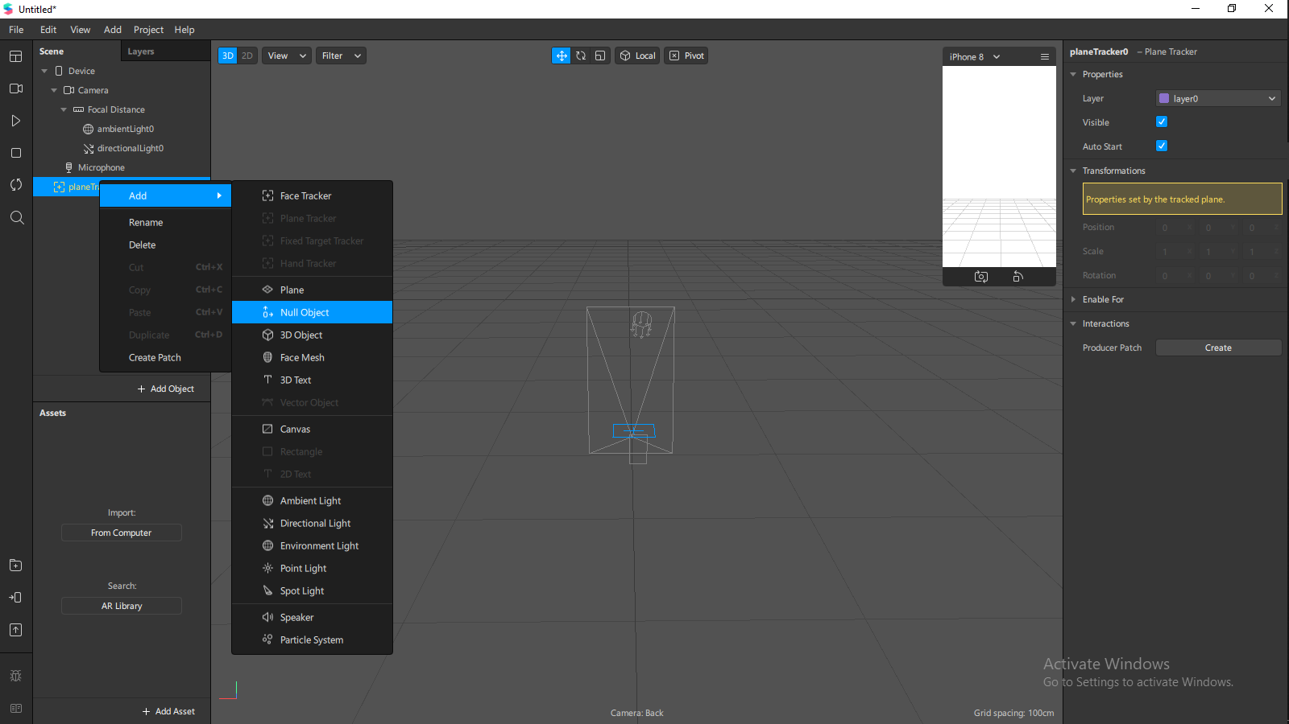

Add an asset from Spark AR Library

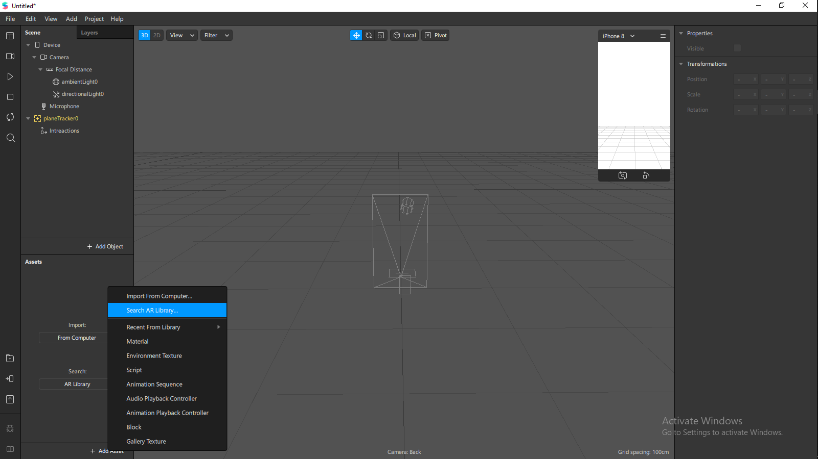

Search Poster and select the Incredibles and Import for free

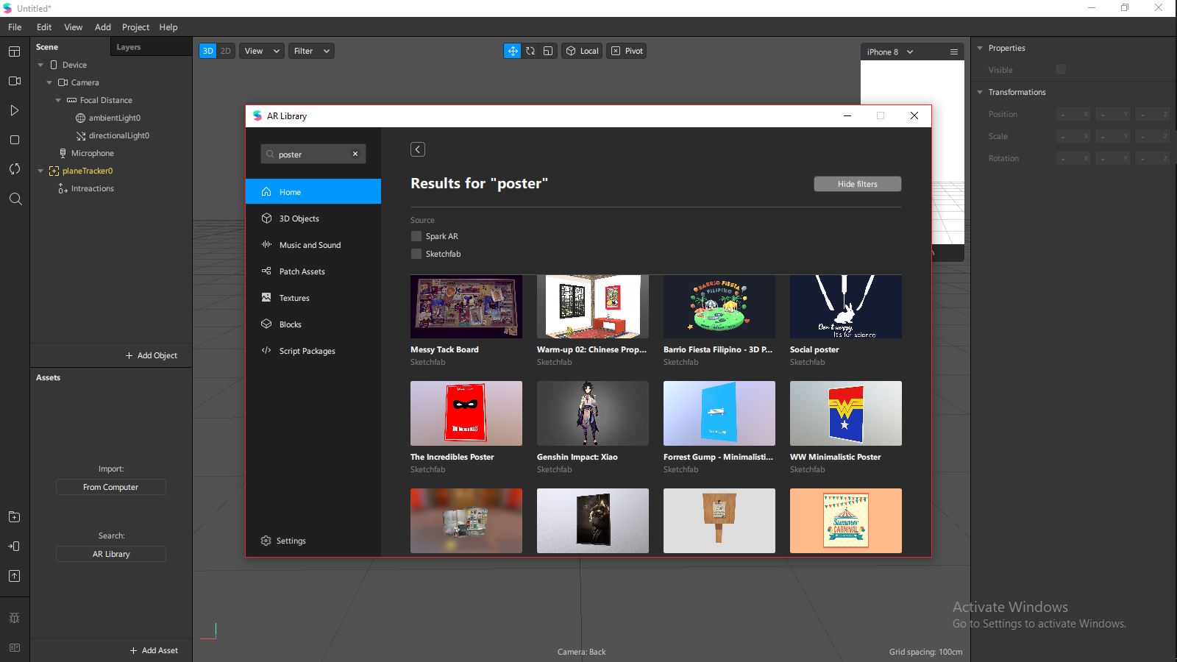

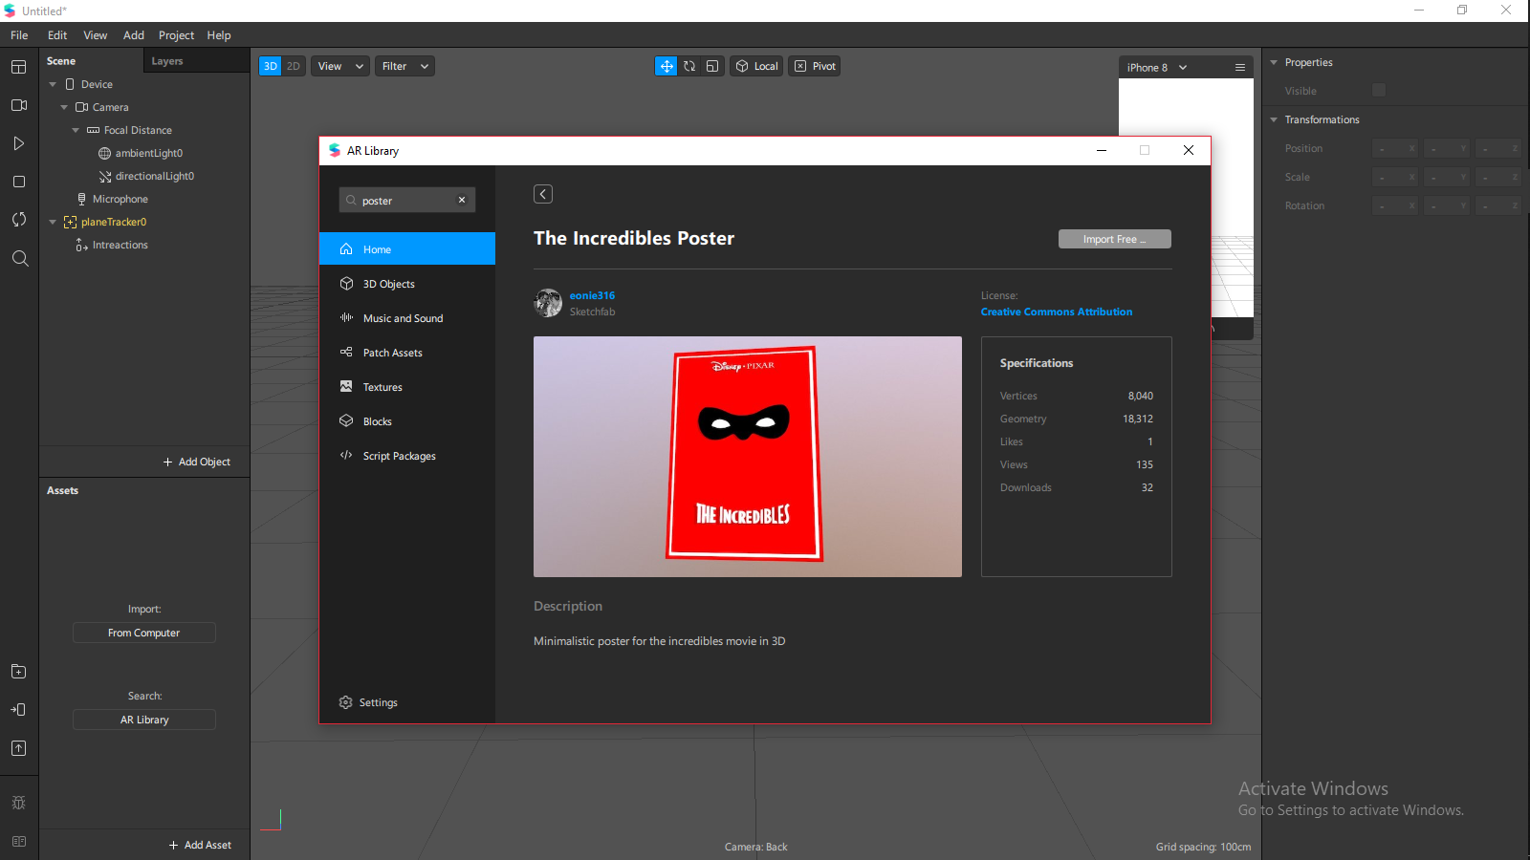

After adding it to your project draw the poster from your assets panel to your scene panel under Plane tracker > Interactions

Delete all irrelevant objects from the poster

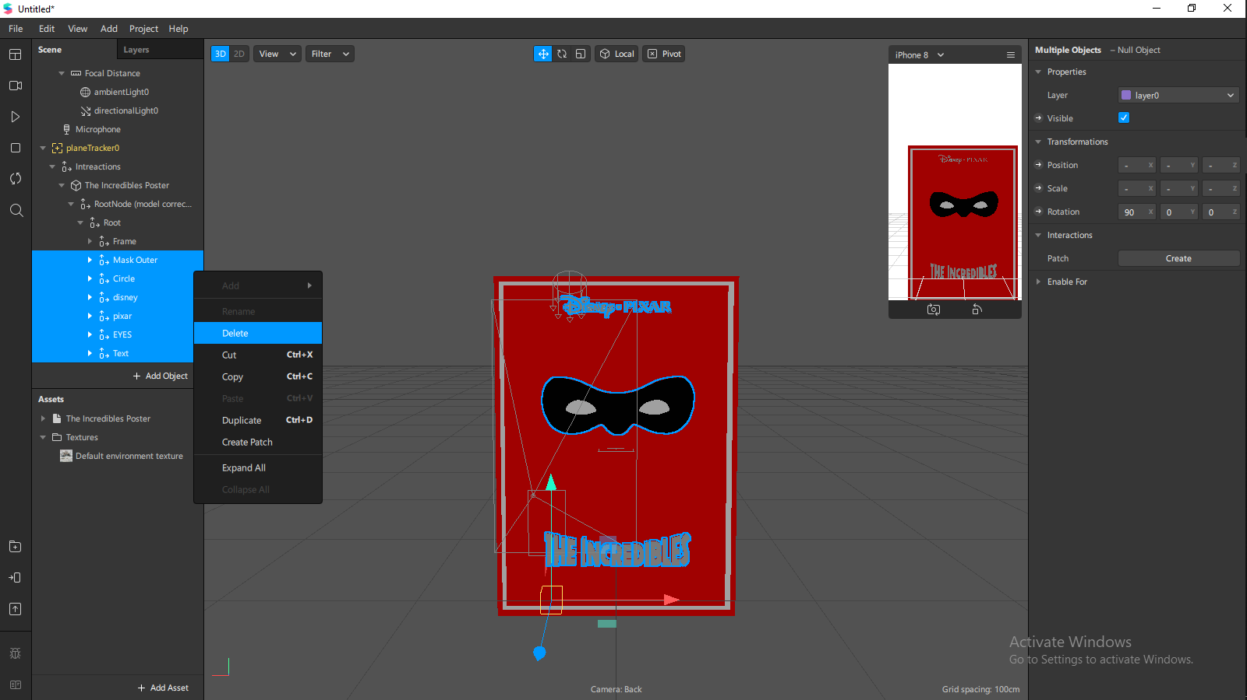

Select the poster materials and change the shader type to flat and also change the color to one of your choice

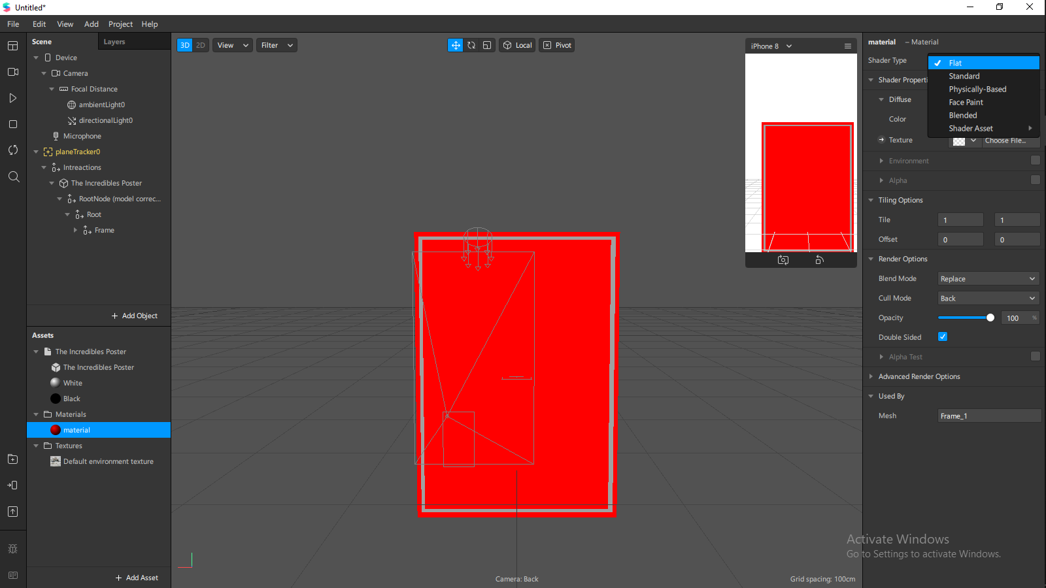

Rename the object the incredible poster to Main

Add a 3d text into the frame of the main Object

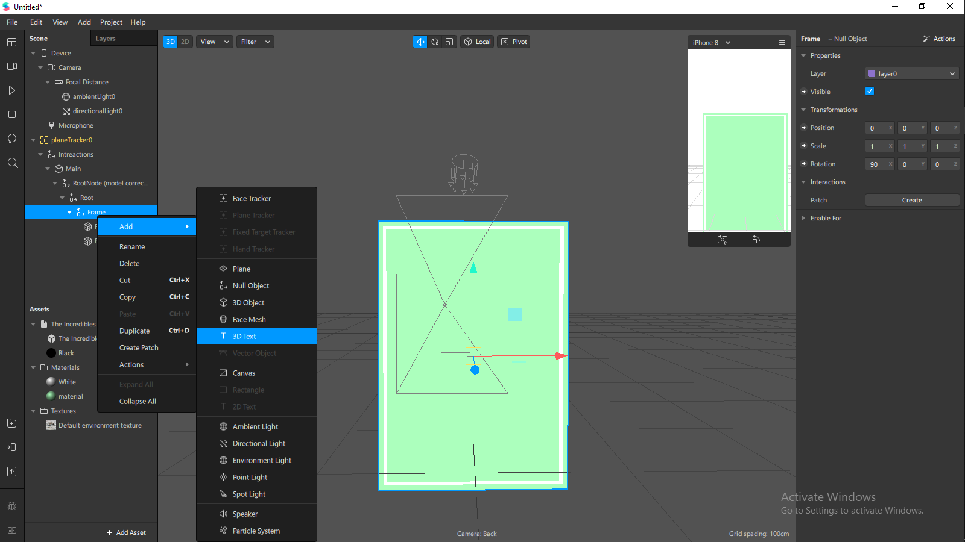

Add a header, change it to size and align it on the background

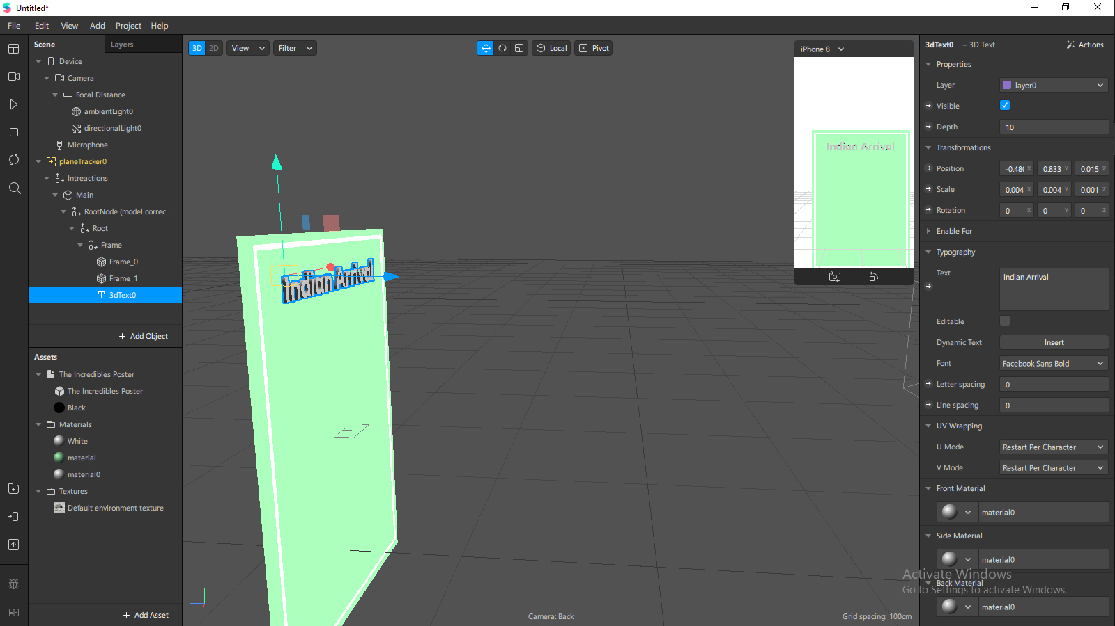

Select the Font

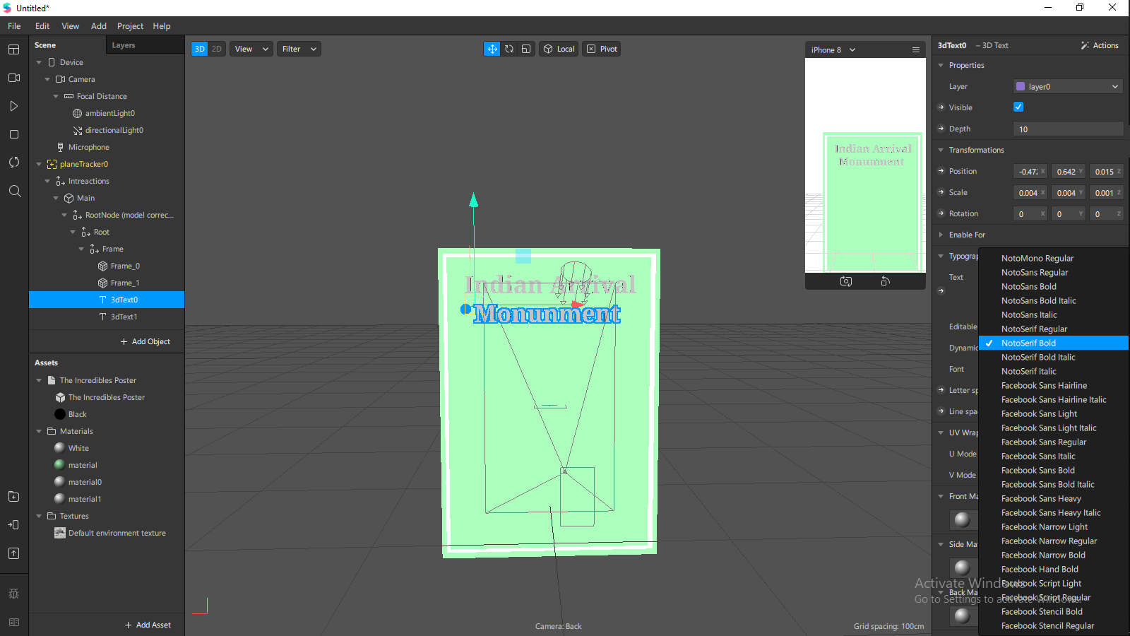

Change the material color to your liking and set shader type to flat

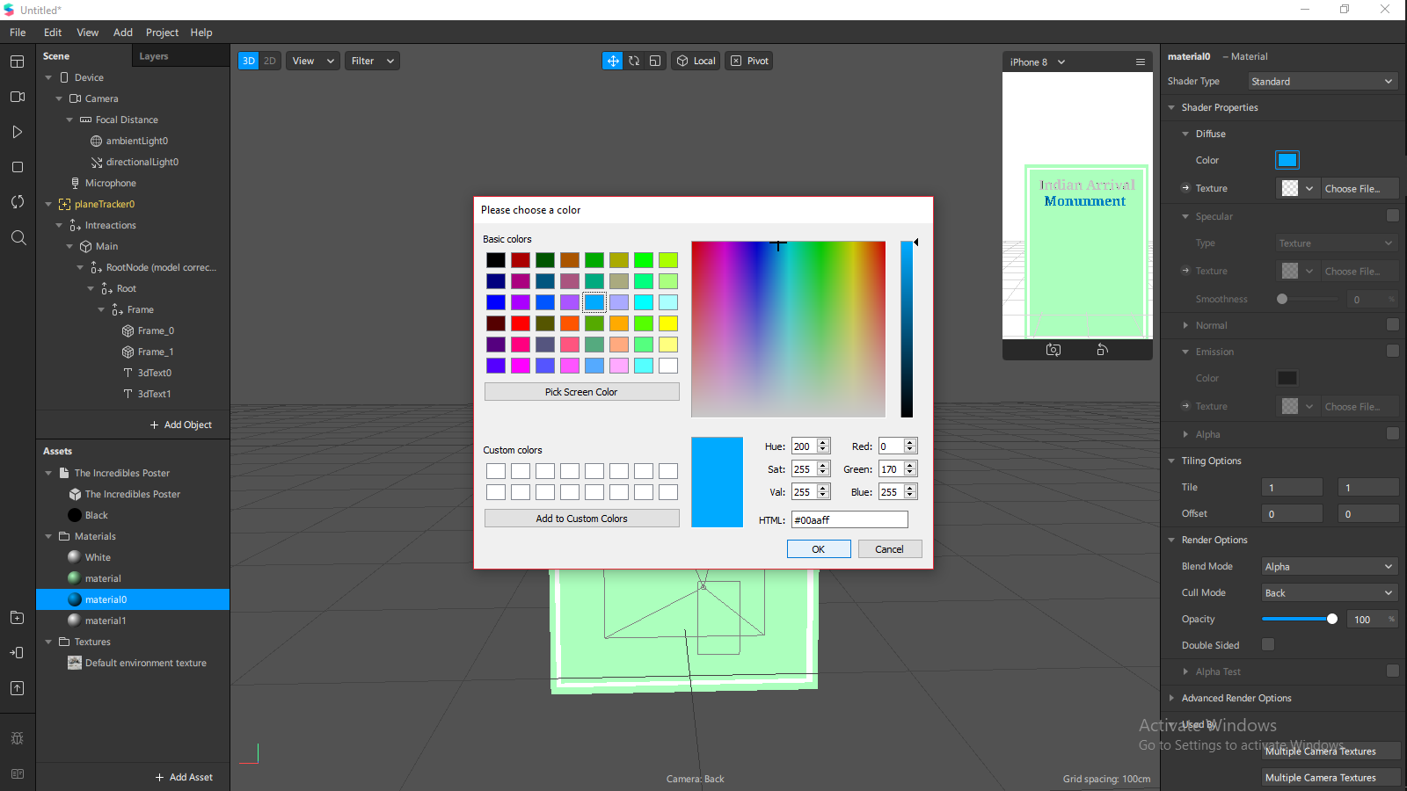

Add a plane in the frame

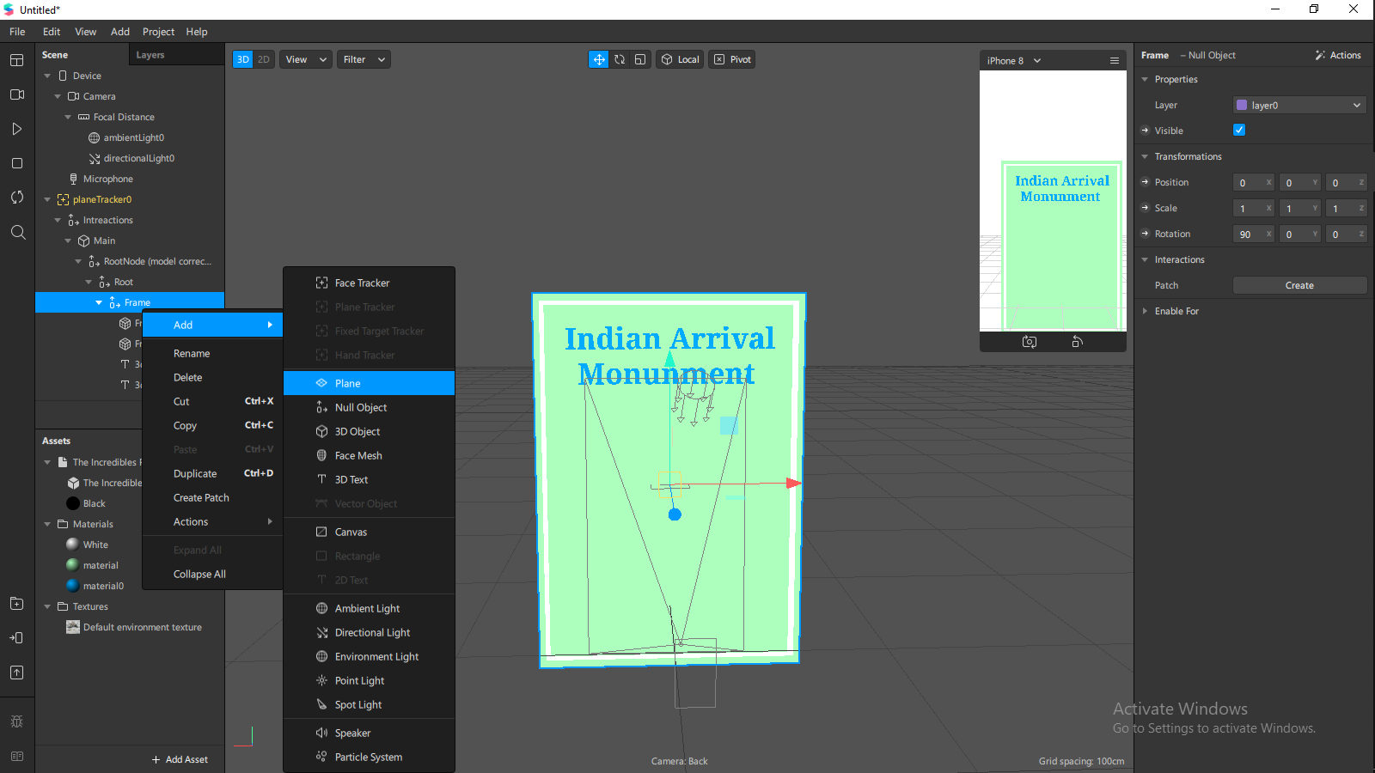

Create a new material and select the 2 flag picture as the texture and set shader type to flat

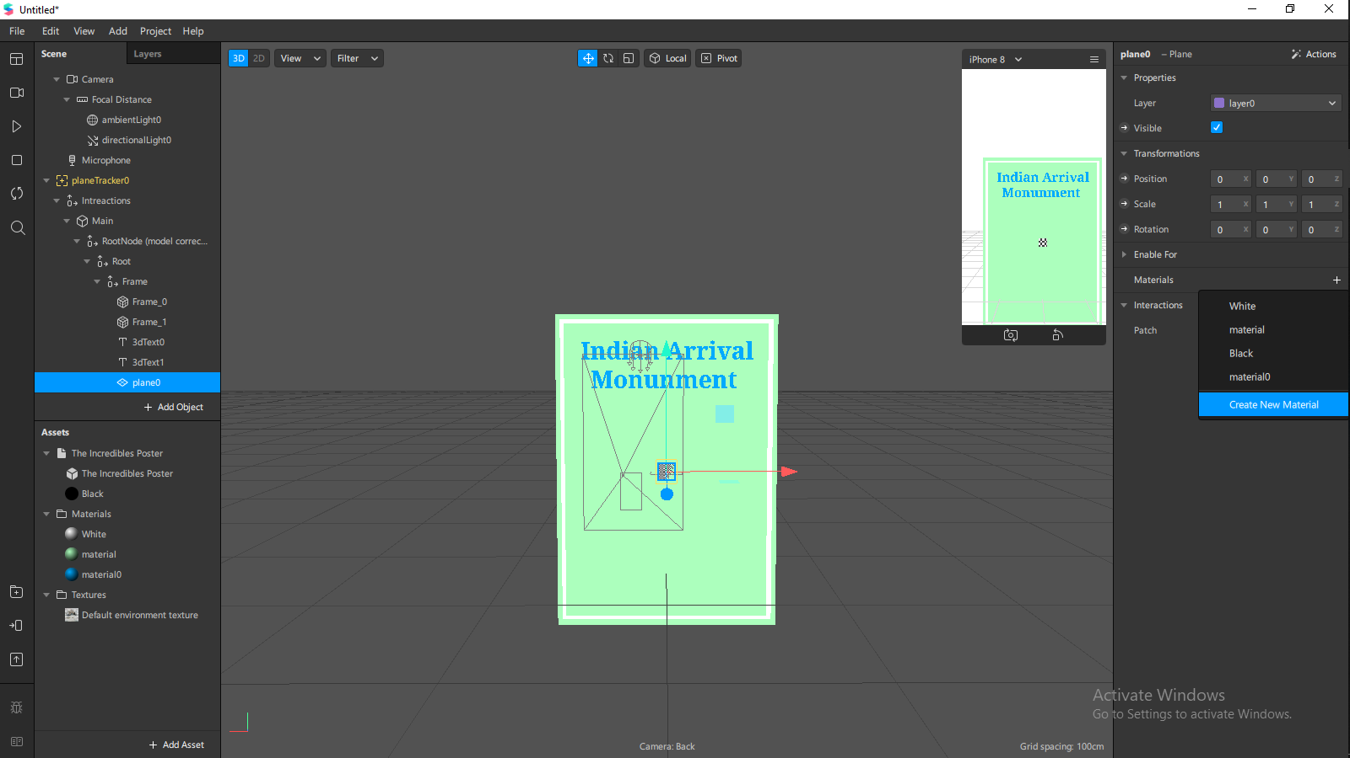

Adjust to a visable size in the centre

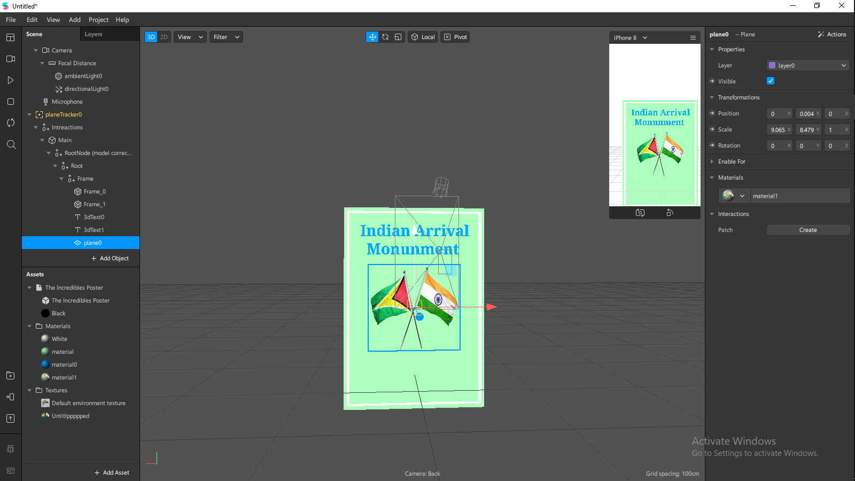

Add a canvas to the frame and change the mode to world space

And adjust it the same size as the poster.

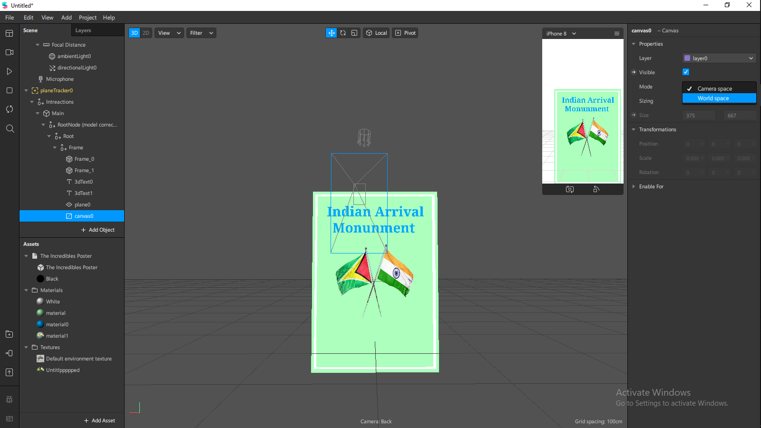

Add two 2d texts to the canvas and change the name to Meaning and More

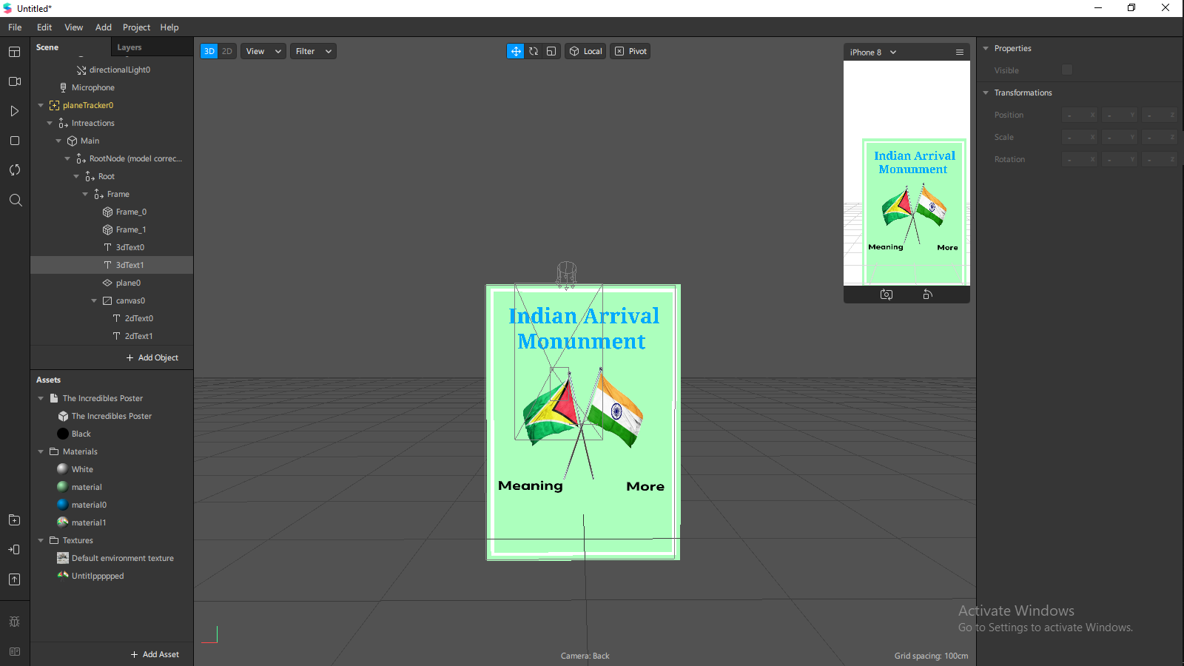

Search in the spark AR library for a button and impost for free and change the material color to your preference

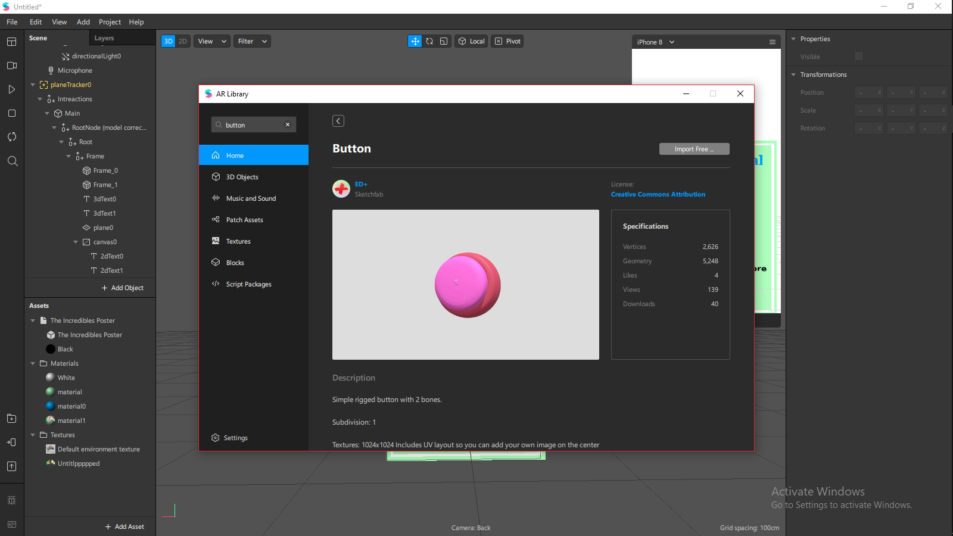

Add 2 button above the text Meaning and More

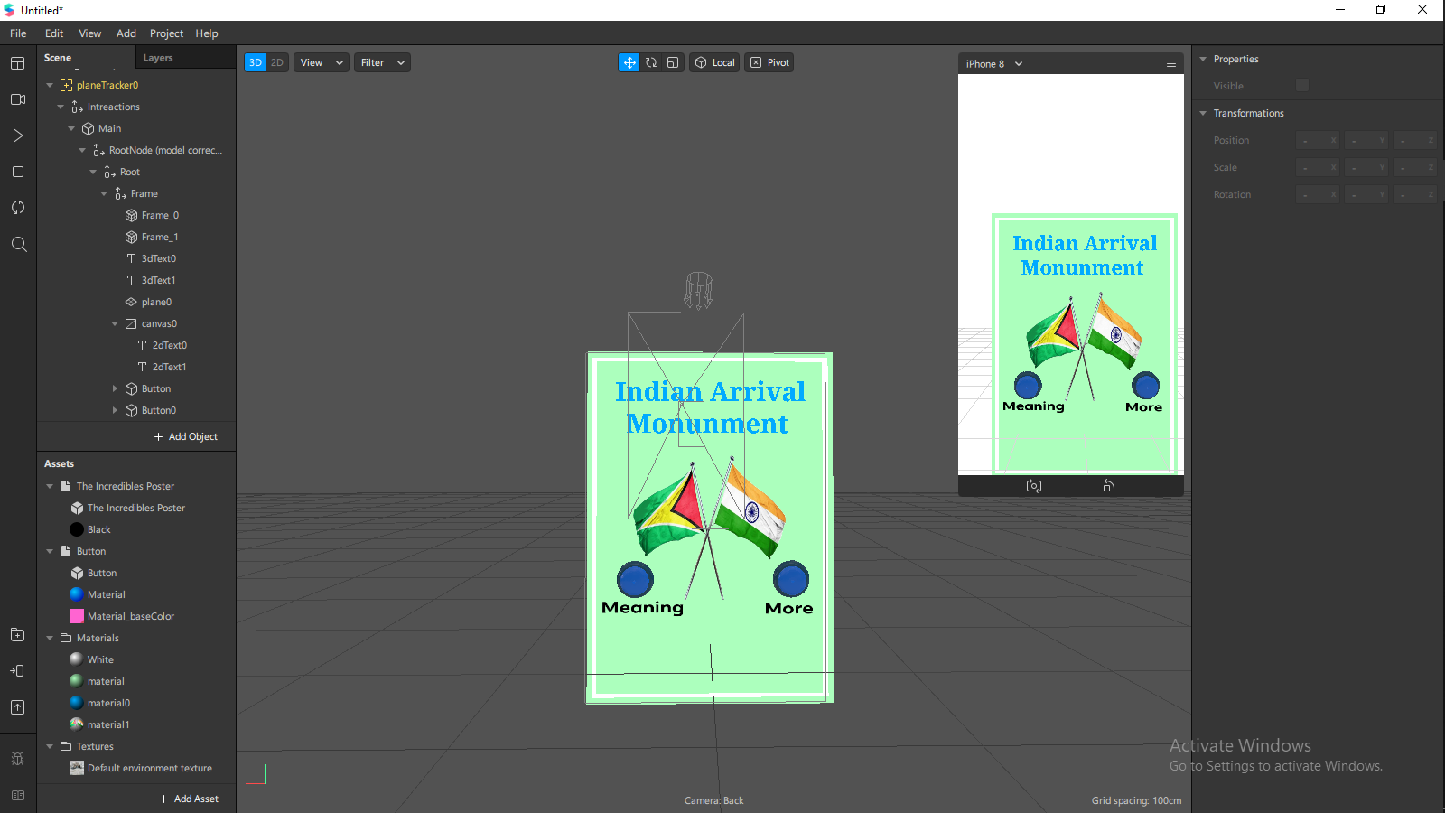

Add another 3d text under the buttons with the location and select the interactions object and set y position to 0.35

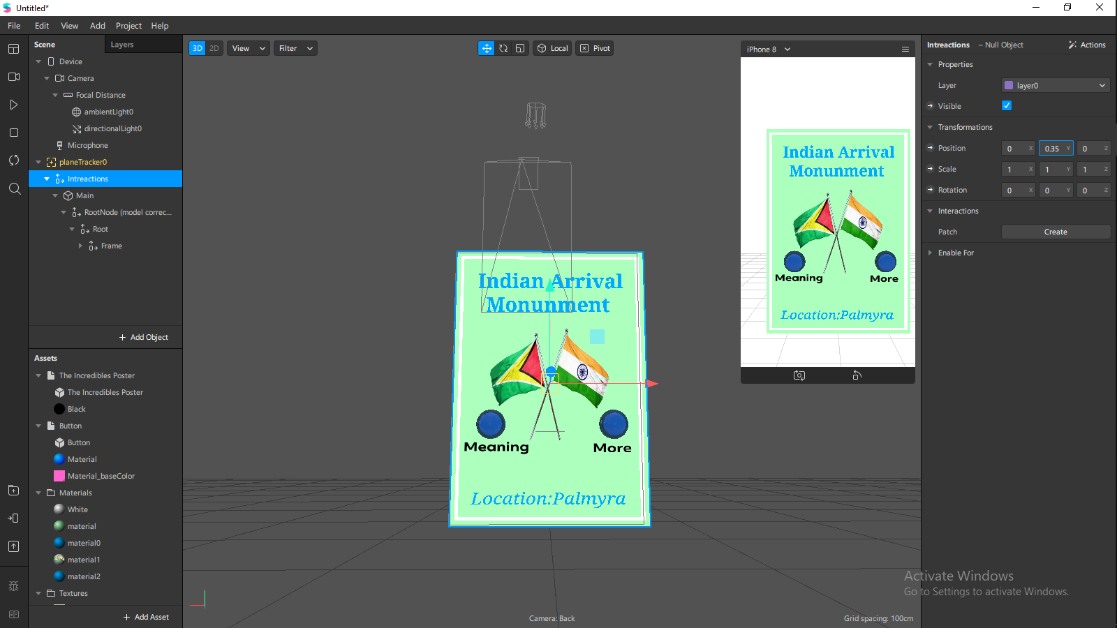

Select the main object and press CTRL+D on windows or Command +D on mac to duplicate and do that twice and rename respectively

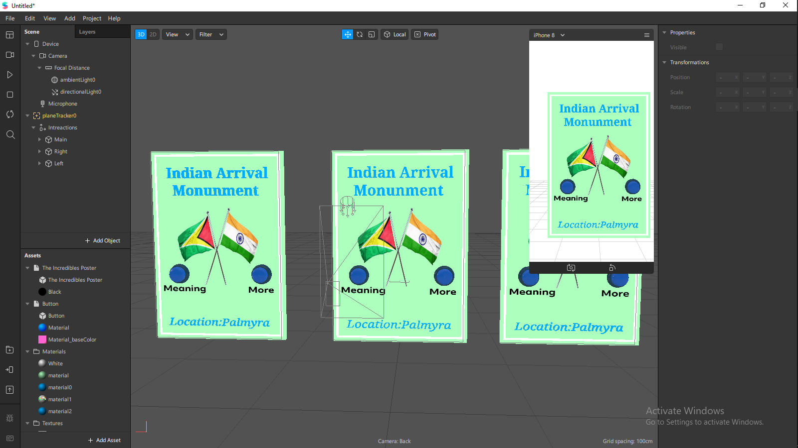

Use the rotation and position views in the viewport to change the objects in a semi-circle view

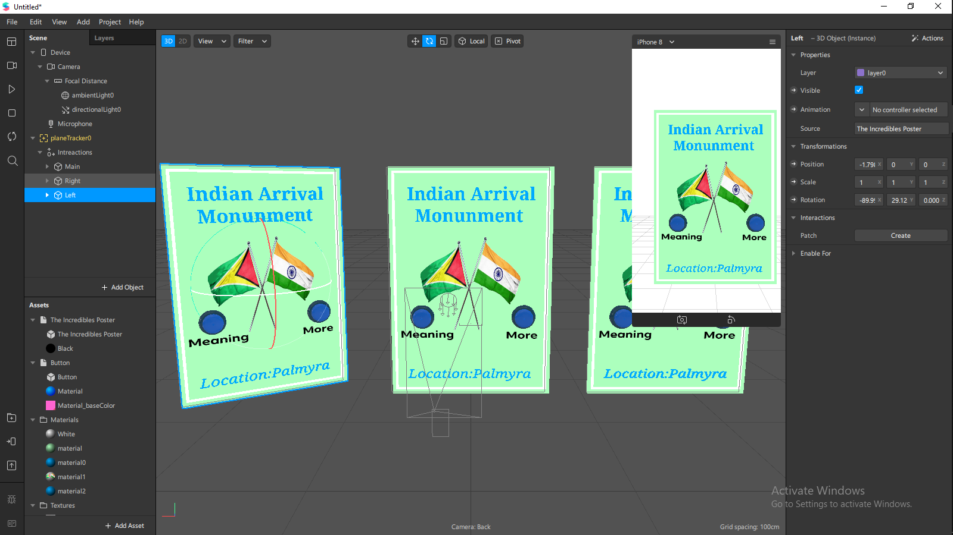

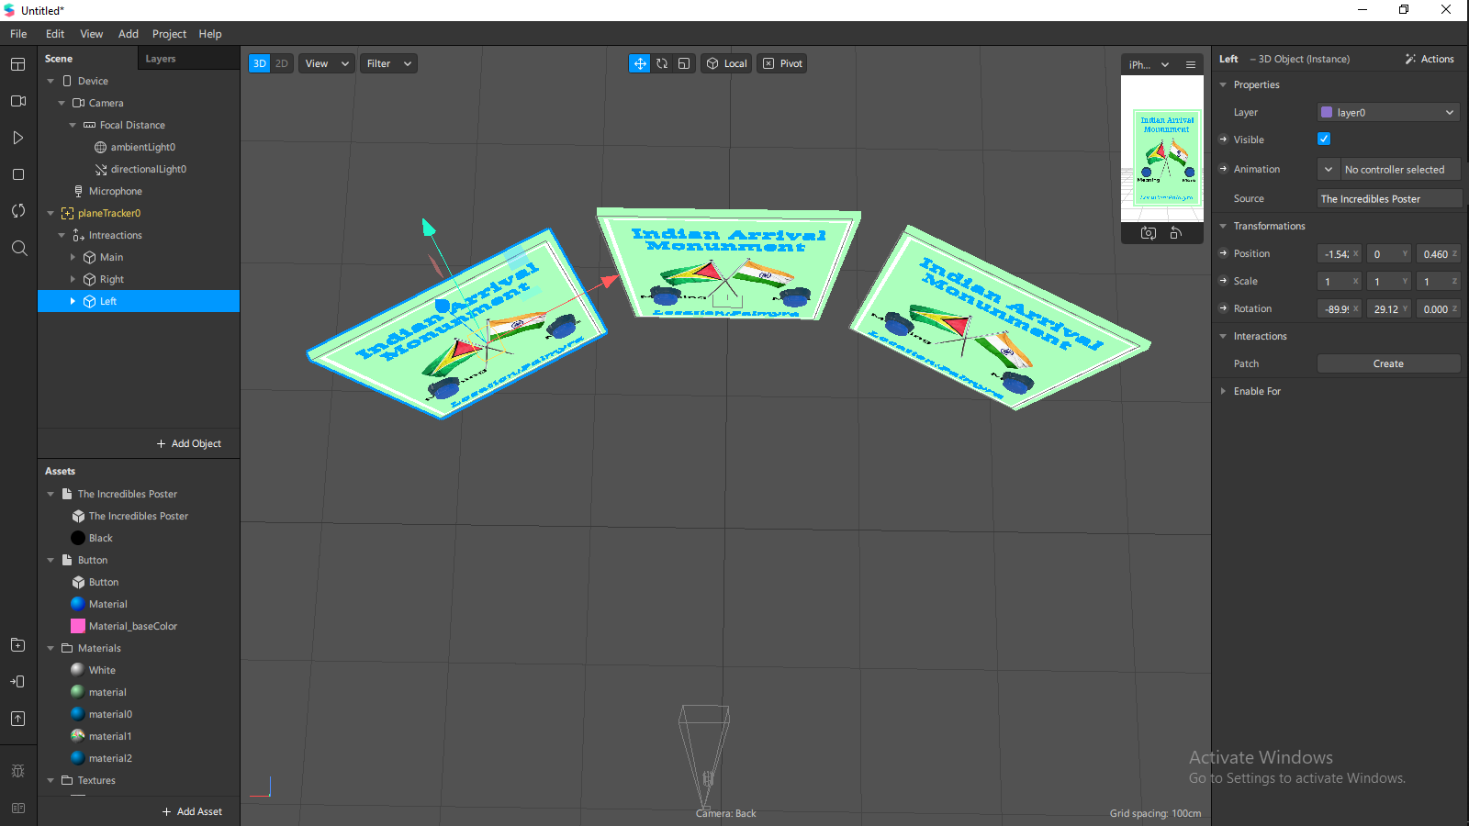

Delete the plane, location, and one button and label from both right and left object and rearrange.

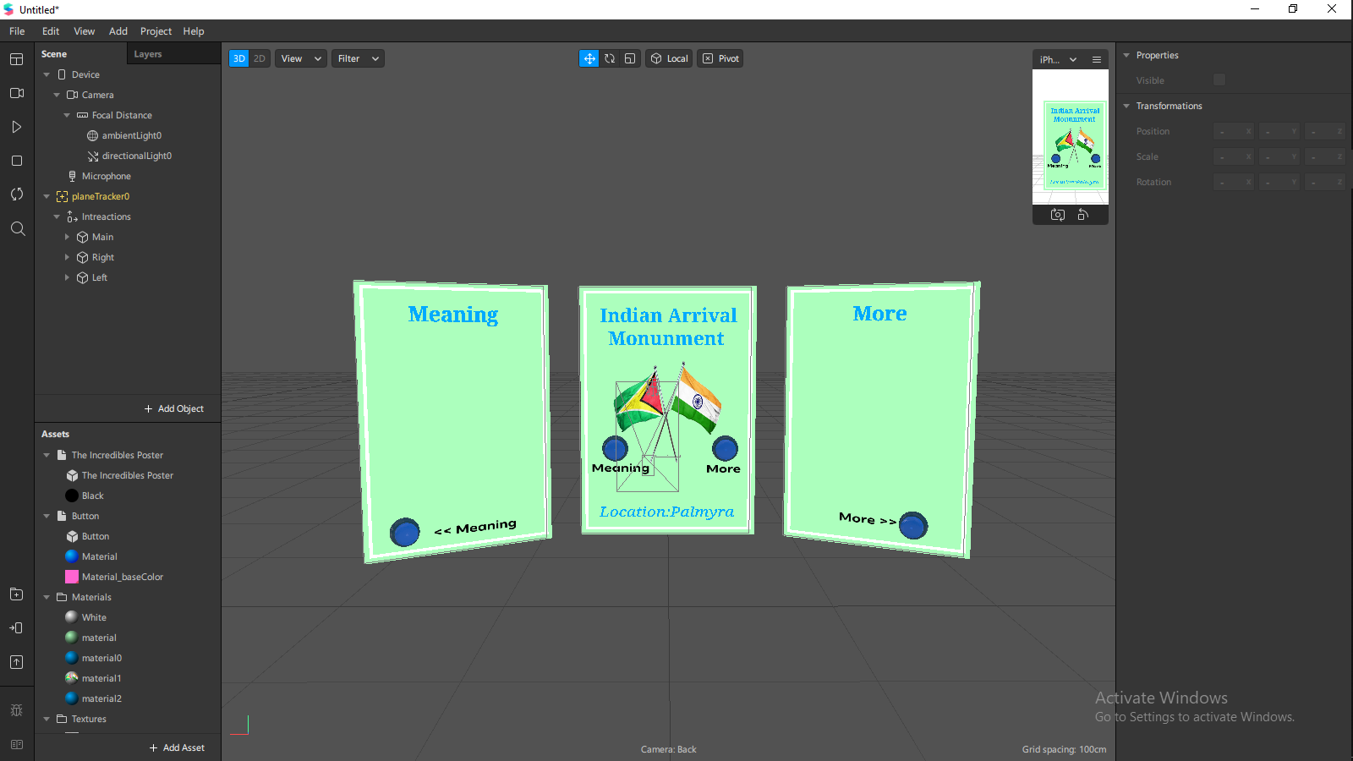

Add in the information about the monument in a 2d text

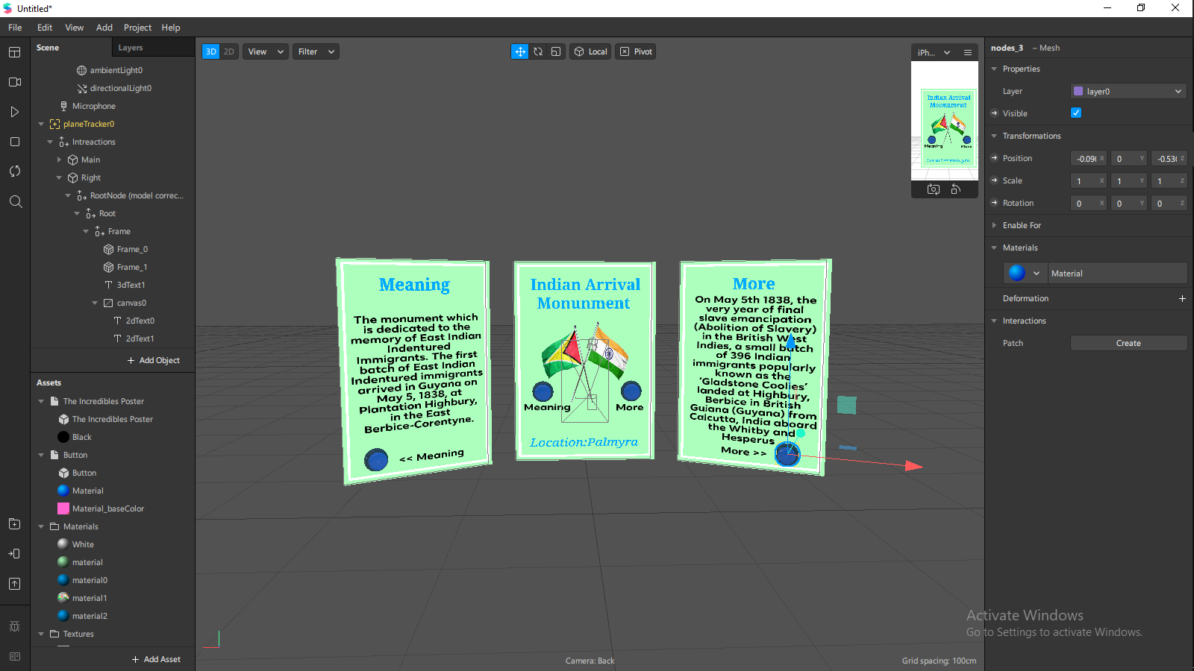

Duplicate the right and left objects and place them outwards and remove the button. And add the relevant texts

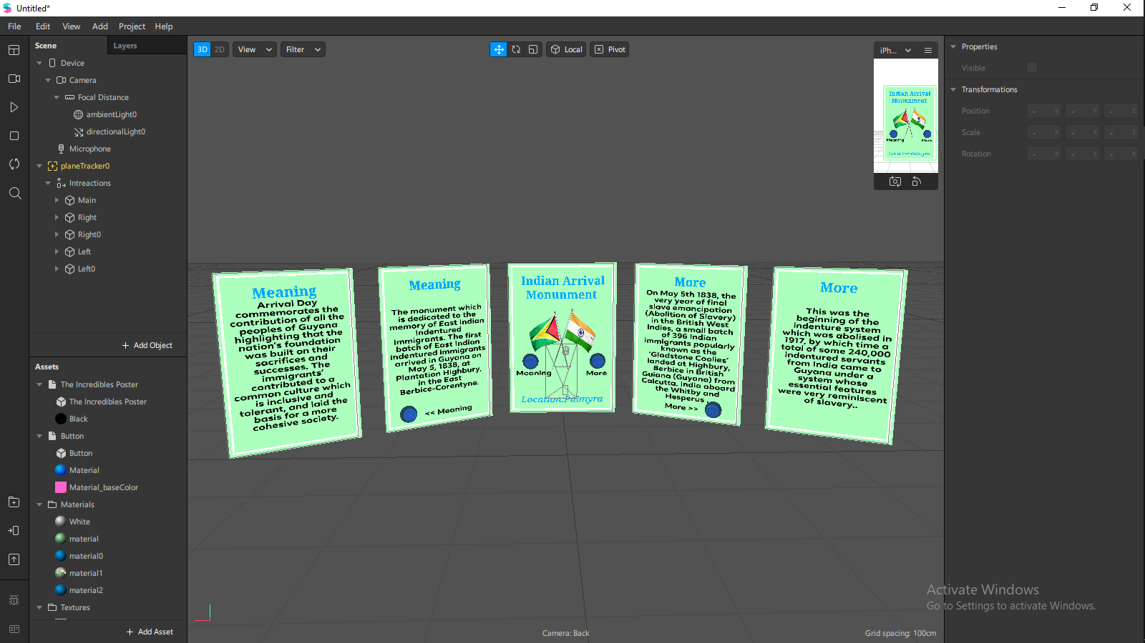

Add 2 emitter to the main object inside the frame section use the flag pictures as the texture respectively.

Set the emitter types to ring, radius to 2, speed to 1, scale to 0.1 and lifespan to 1.

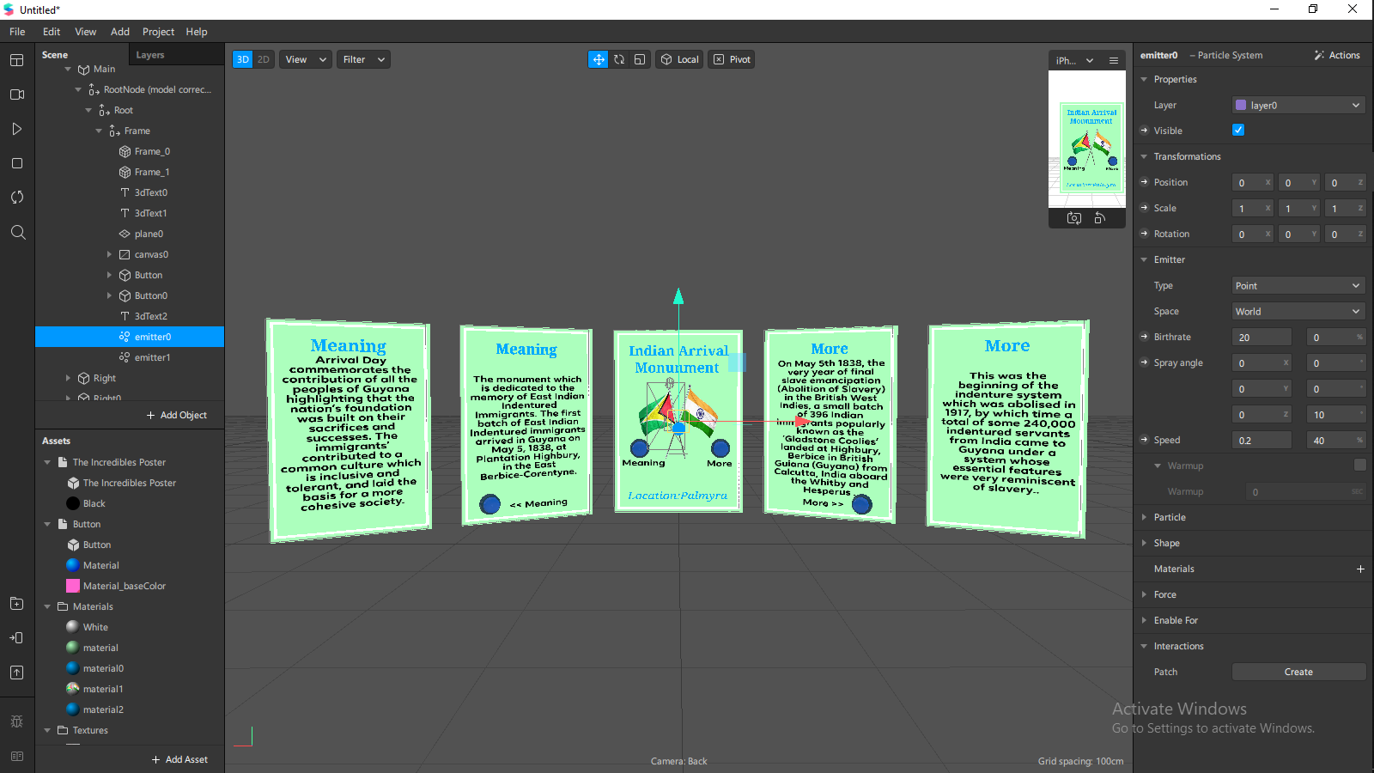

Animate all the objects expect for the main with a float animation

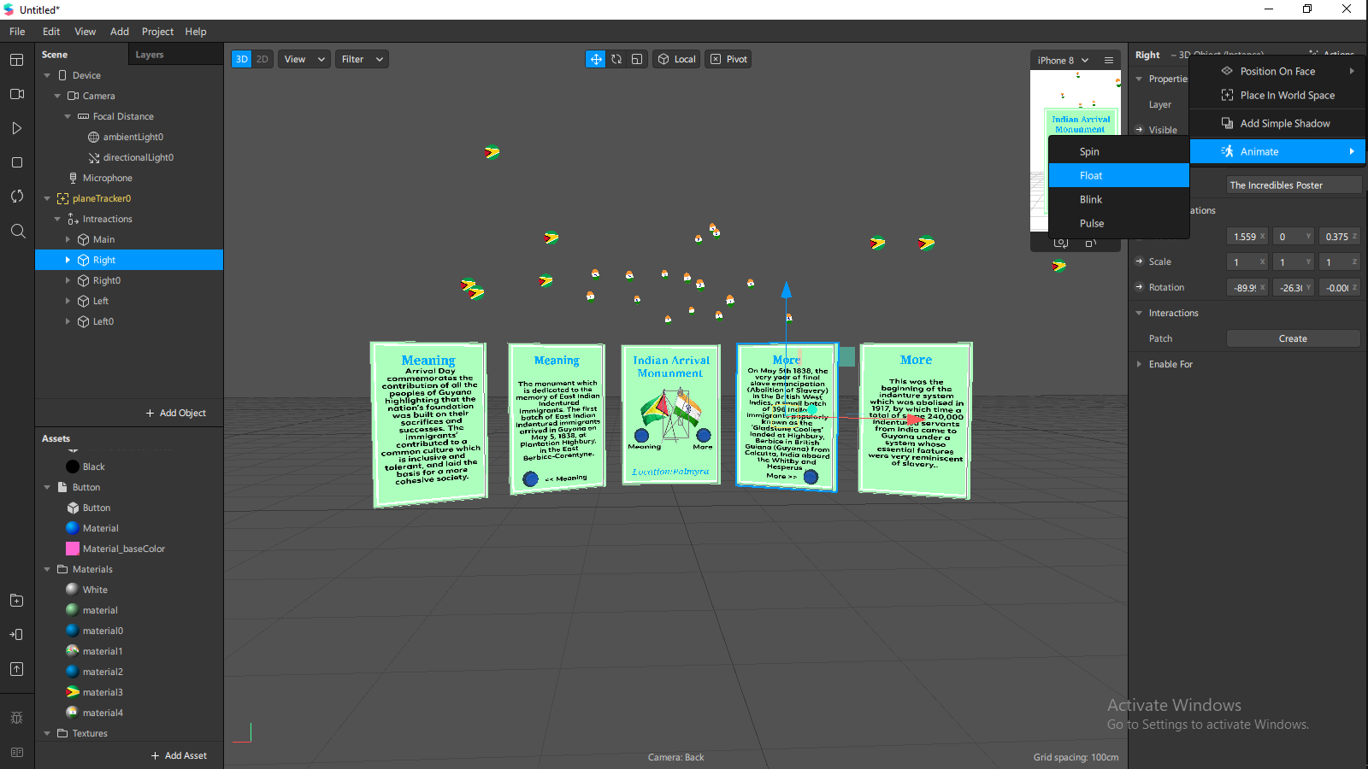

Patch Editor

**Patch for the objects to move**

Open patch editor and add a patch called screen pan

Add a patch called divide and change the settings to vector 2

Connect the 2d offset from the screen pan to the first value of the divide patch

Add a patch called unpack and change the settings to vector 2

add a patch called pack now connect the first unpack value to the first pack value

select the last unpack value and connect it to the last pack value

add the interaction position patch by selecting the interactions object from the scene panel and then selecting the small arrow besides position and connecting the pack output to the interactions input.

Screen pan>Divide>Unpack>Pack>Interactions

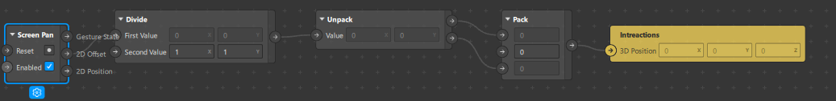

Patch to change scale of object

Add a patch called screen screen pinch

Add a patch called pack and connect the scale to all of the available spots on the pack patch

Add the interactions scale patch by selecting interactions from the scene panel and then selecting the small arrow besides scale and then connecting it to the output of the pack patch.

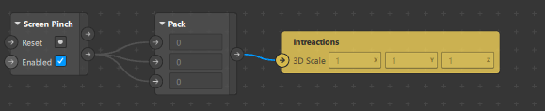

Using patches to make the buttons interact

Create an object tap for the buttons on the main object

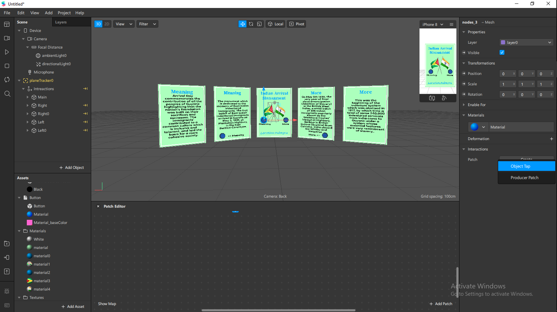

Select the object to the left and create a visible patch

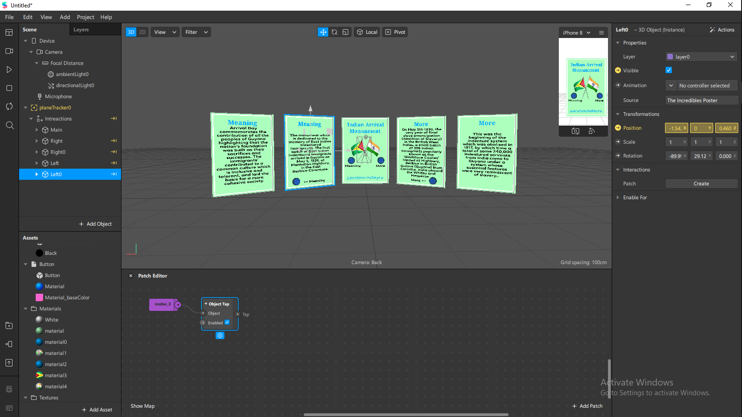

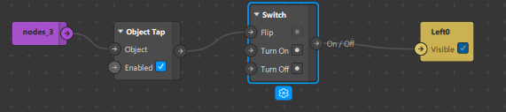

Repeat for all buttons

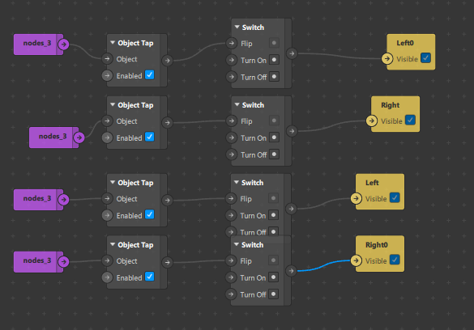

Make the middle picture a button to show particle effect and play a sound with patch editor

Create a patch for object tap

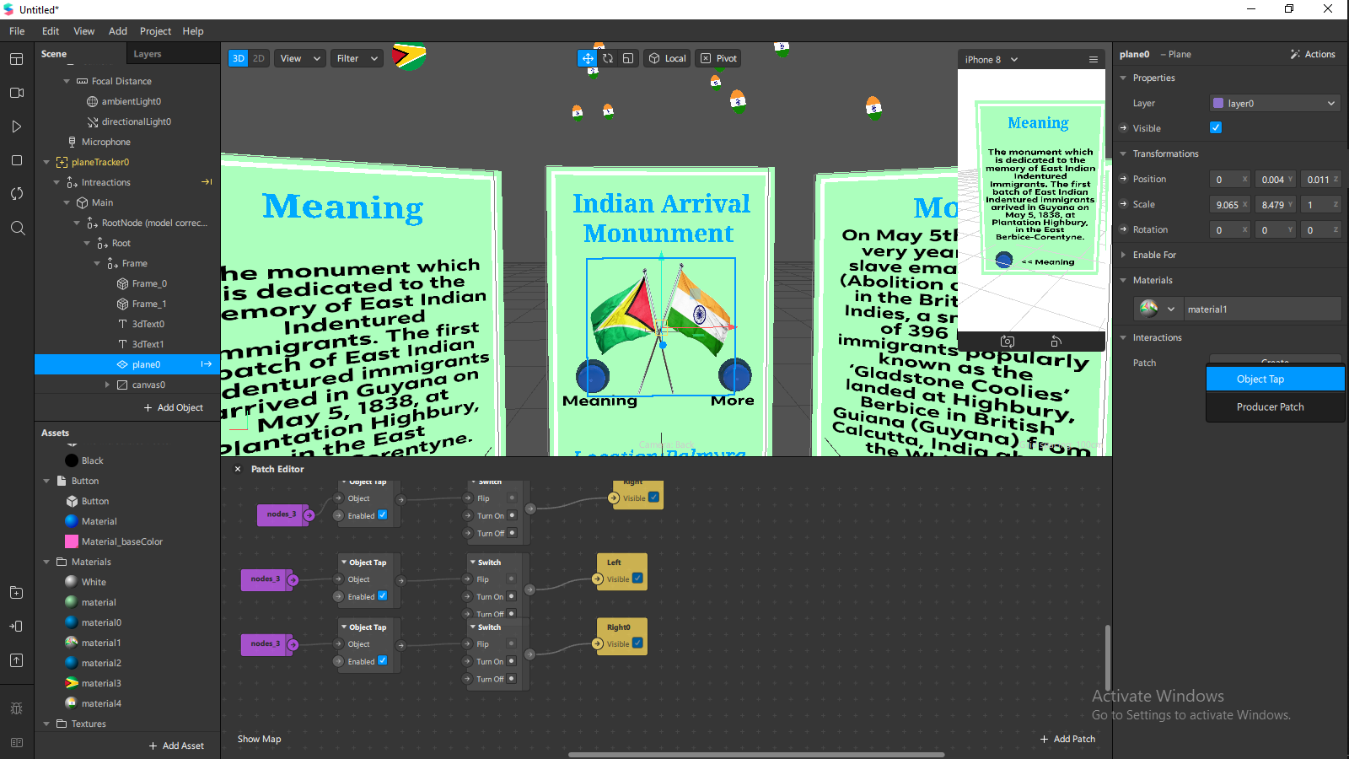

Create a visible patch for the emitters

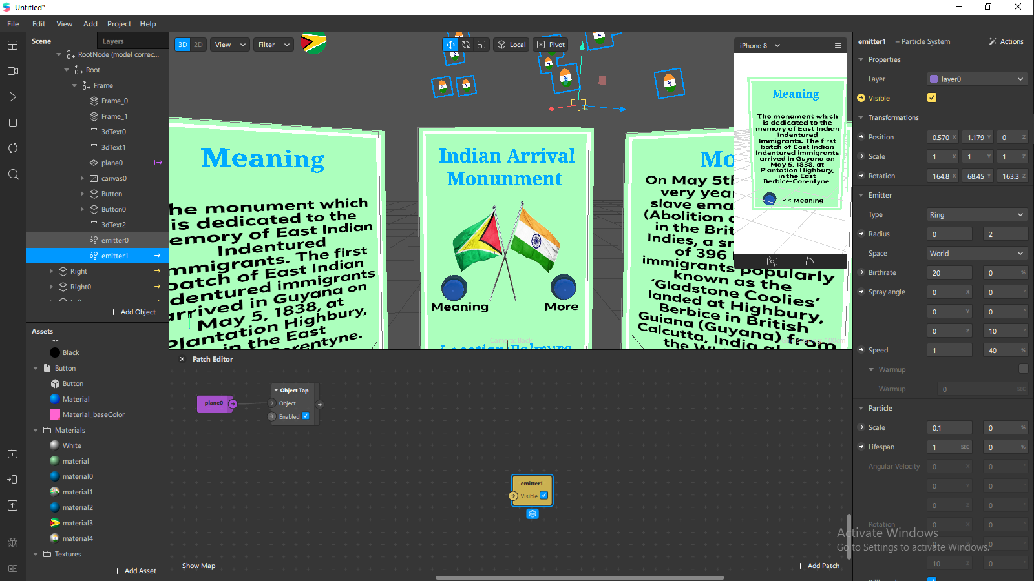

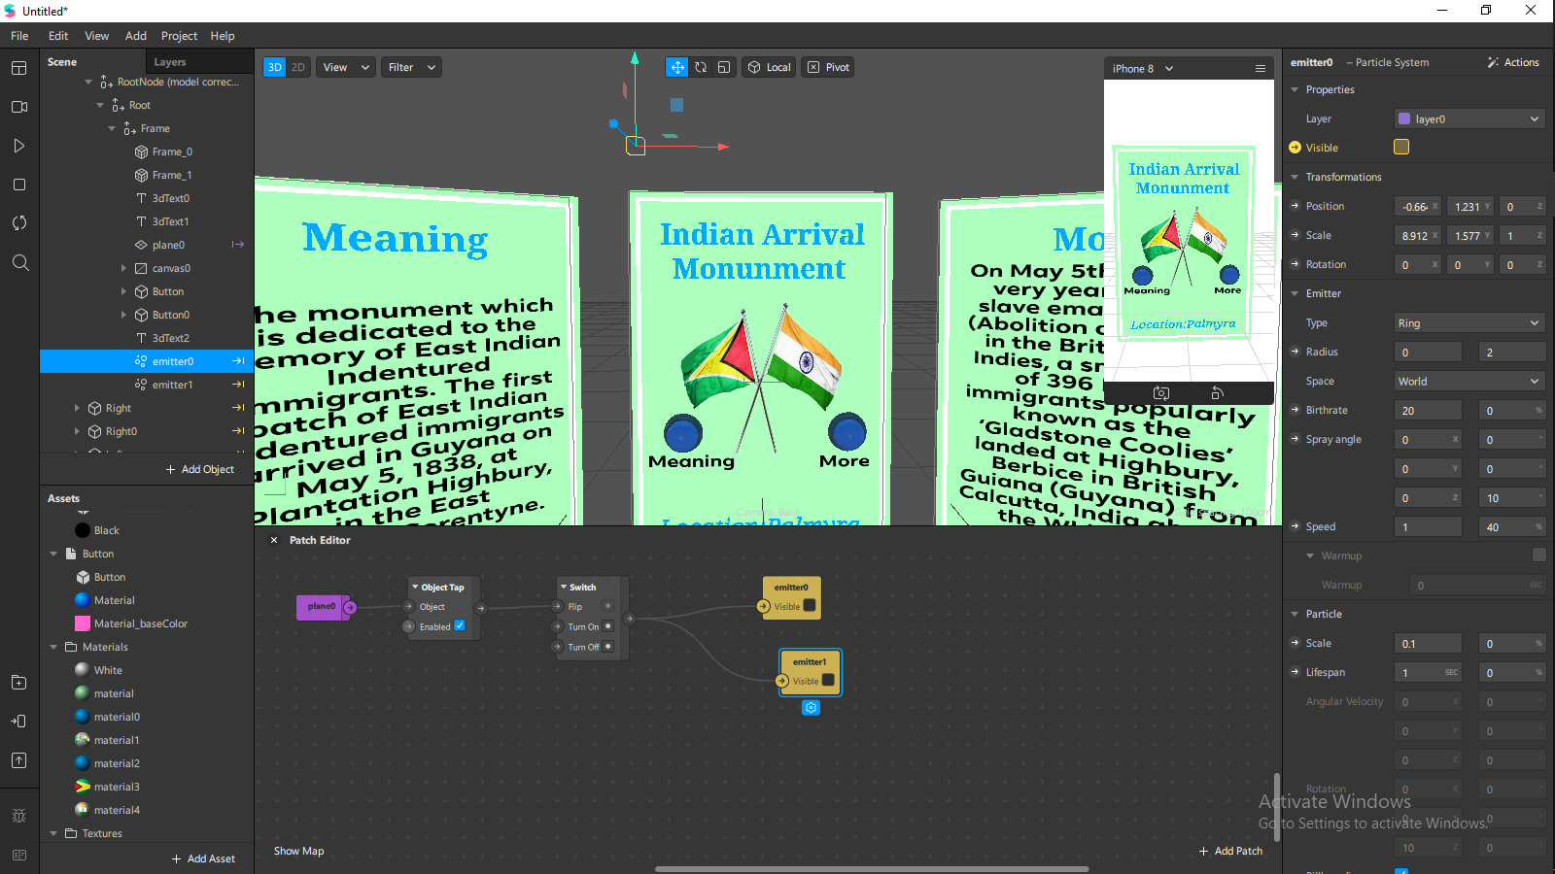

adding an audio player patch

import a sound file from the spark AR library for free

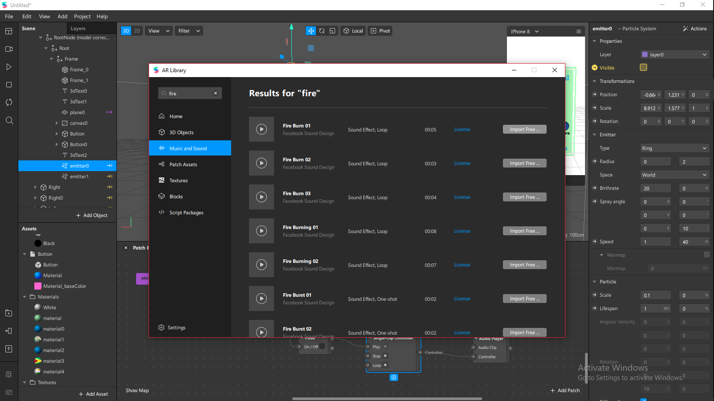

Add a single clip controller to the audio player

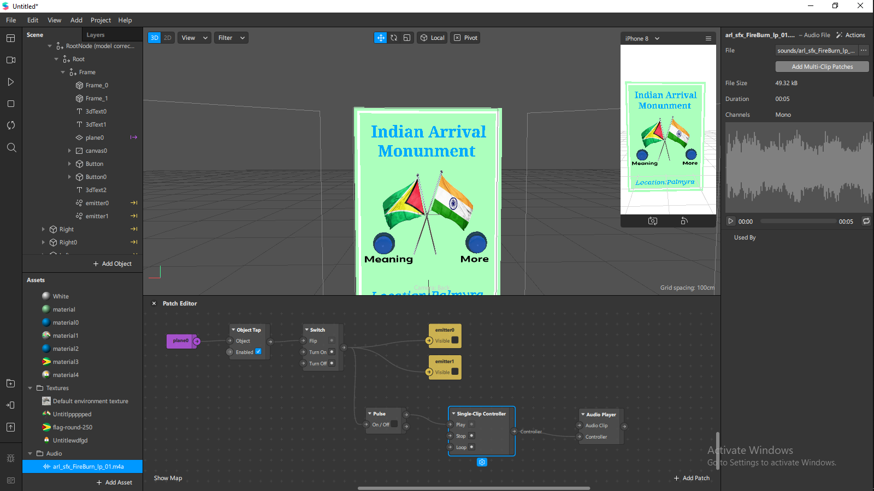

Add a speaker to the scene panel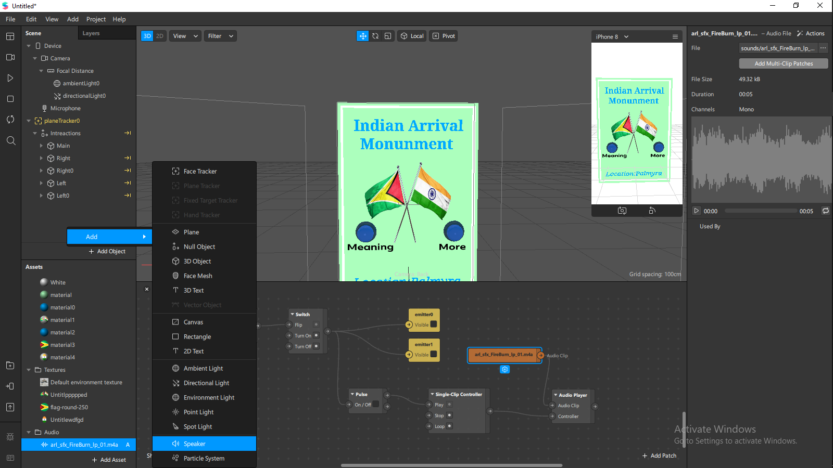

Drag the audio clip into the patch editor and connect it to the audio clip section

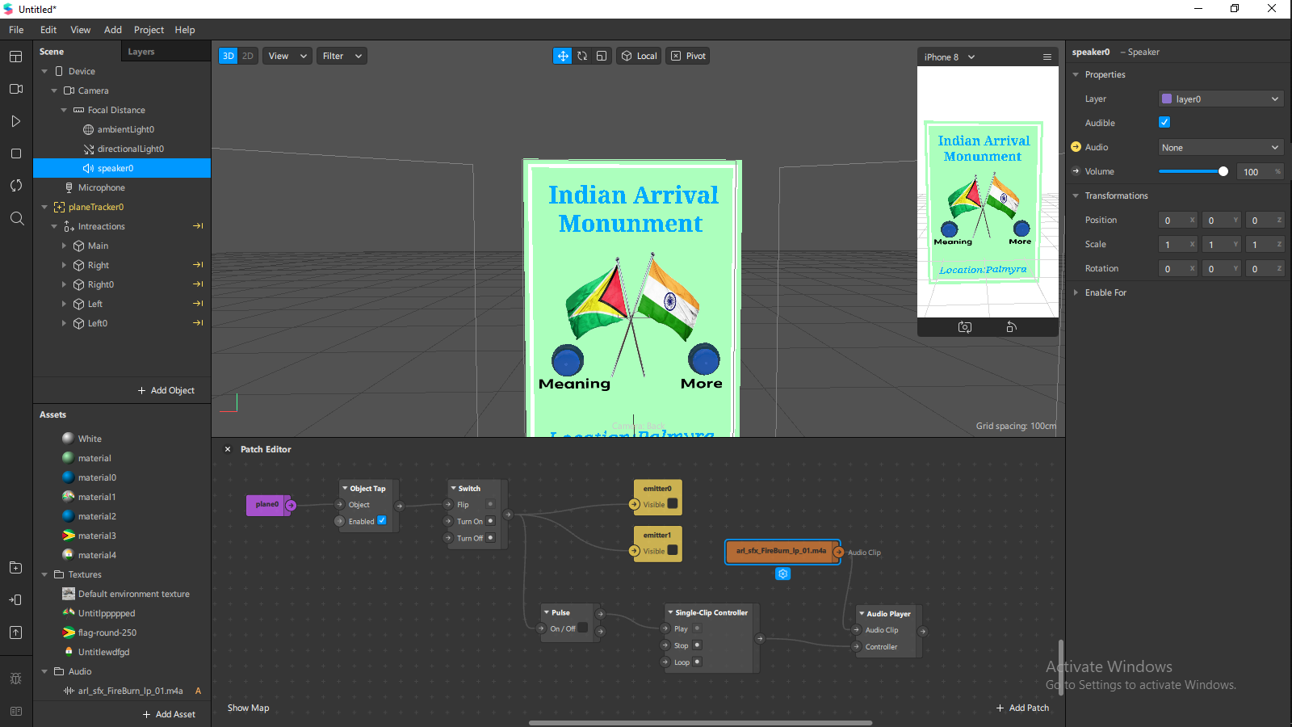

Add the Speaker audio patch by selecting the small arrow besides audio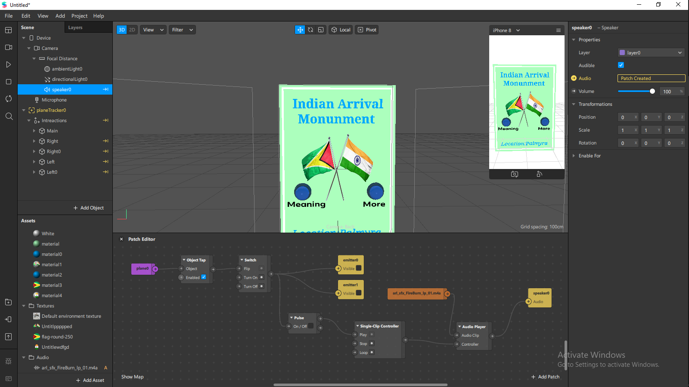

Expected Results

